**The Open University of Sri Lanka Faculty of Engineering Bachelor of Software Engineering Department of Electrical and Computer Engineering**

**Project Proposal Report**

**Project Name: Visit Sri Lanka Travel and Tourism Website**

**Group Name: Cloud4**

**Group Members: M.A.C.M. Sumail - S92068923**

**I.N. Jahan - S92068909**

**A. Afni Ahamed - S92075238**

**M.Y. Azeez Ahamed - S92077064**

**Table of Contents**

1. Executive Summary

2. Product Description

2.1 Problem we solve

2.2. About the product

2.3. Unique Features

2.4. SWOT Analysis

3. Market Analysis or Current Problem analysis with a DFD

3.1 Competitor analysis - write at least 5 features and do the comparison with 3 similar systems available in the market or that you know

4. You should write the work distribution among yourselves and the operational plan based on our deadlines

5. Milestones and Reporting

**1. Executive Summary**

We are going to develop a successful web application for travel and tourism, and it will be used to hold all the booking, creation, management, and tour information for travel administration tourism packages in the database. The software will be thoroughly tested, and any flaws will correctly debug. Our team decide to test reveal that the system's performance is sufficient. The entire required production will be produced. Thus, this system offers a simple method for automating all consumption-related tasks. This programme will be useful if just a small number of people use it. The project can yet be improved, making the website run much more attractively and effectively than it does now. It may be said that the application meets the needs and functions well. The software is thoroughly tested, and any faults are properly debugged. It also serves as a means of exchanging files with important sites.

# **2. Product Description**

## **2.1 Problem we solve**

* + - Poor Kerning, Tracking, & Leading
    - Badly Integrated
    - Slow Website & Server Response Time
    - When Navigation Becomes ‘Complication’
    - Content Only Embellishes our Business
    - No Privacy Policy & Security Issues

## 

## **2.2. About the product**

* Prior to kerning, concentrate on tracking and leading. Why? Because the total distance between the groupings and the letters is known as tracking. Try trying various things while maintaining an equal apparent distance between the letters. Keep our style free.
* To draw visitors to our website, highlight reputable clients. Increase our efforts and spread the word; this is the most efficient way to increase involvement. Let's examine issues with website design and potential solutions from the standpoint of the projects.
* Want to improve the functionality and speed of our website? Pick a trustworthy web hosting company. If we upgrade your hosting plan, the slow performance will disappear. Caching is a useful method for speeding up a server's response time. Make sure our server is adequately optimised to cut down on server time.
* We will lose visitors if our website lacks a navigation bar or search tool. If we want to make it easier for people to navigate many web pages on our website, we may utilise breadcrumb navigation. In addition to reducing the number of steps a website user must take to reach a higher-level page, it also makes website sections and pages easier to discover. It is a powerful source of contextual information for landing pages and serves as an efficient visual aid that demonstrates the user's position within the website's structure.
* Make sure our material is tailored to the demands of our audience. There is absolutely no value to the material if the visitor isn't the primary emphasis. our content will bring in more money for us if it fully addresses the queries of our visitors.
* It's completely barbarous to provide details like our contact information in FAQs or other Q&A-style nonsense. Make sure our website has easy access to our contact details. It's hard to imagine, but organisations like Microsoft and Amazon did a horrible job of offering any comprehensible contact information. But this bad behaviour is fatal to small firms. Without even letting them know, it may cause them to lose their leads and reservations. Today, some businesses operate using the "live chat" feature, which is also a fantastic method to turn enquiries into appointments.

## **2.3. Unique Features**

The four basic characteristics of tourism services—intangibility, heterogeneity, perishability, and inseparability—distinguish them from other manufactured items. First, since they cannot be examined or tested in advance of a purchase, tourism services are intangible. These sections were developed to make it simple for people to share their experiences managing and preventing over tourism. Limits of Tolerance for Change Priority Access for Locals, Temporary Residents, Tourist Tax, etc. matching supply and demand. Town and city planning, transportation, etc.

## **2.4. SWOT Analysis**

SWOT analysis is a strategic planning method used to evaluate the strengths, weakness, opportunities and threads involved in any project under study.

**Strength**

* Attractive location and pleasant weather.
* Existing travel industry.
* High biological diversity
* There are many different terrestrial and aquatic eco systems.
* Various Land Scope
* More variety in terms of history and culture.
* Worldwide accepted benchmark for lodgings
* Skilled workforce in the sector.

**Weakness**

* Increased government involvement
* To facilitate the expansion of the tourism industry, there is enough infrastructure.
* Maintains a focus on conventional tourist fare.
* Administration of tourism locations appropriately.
* Specialties in onsite interpretation education are not present.
* lack of national policies supporting the growth of the tourist sector.
* Most hotels are in the city.
* Strong in terms of lodging options.

**Opportunities**

* Good opportunity for success or advancement.
* Possibilities for new markets and travel products.
* Opportunities for accommodating the law's costs.
* Research and development aimed at enhancing the nation's economy and security.
* Introducing fresh tourism themes through resource assignment.

**Threats**

* Fierce rivalry between Asian nations.
* Environmental and social devastation brought on by widespread tourism.
* Directly competing with alternative replacements.
* Impact on the global oil price.
* Tourist product diversity is lacking.
* Inadequate infrastructure.

# **3. Market Analysis or Current Problem analysis with a DFD**

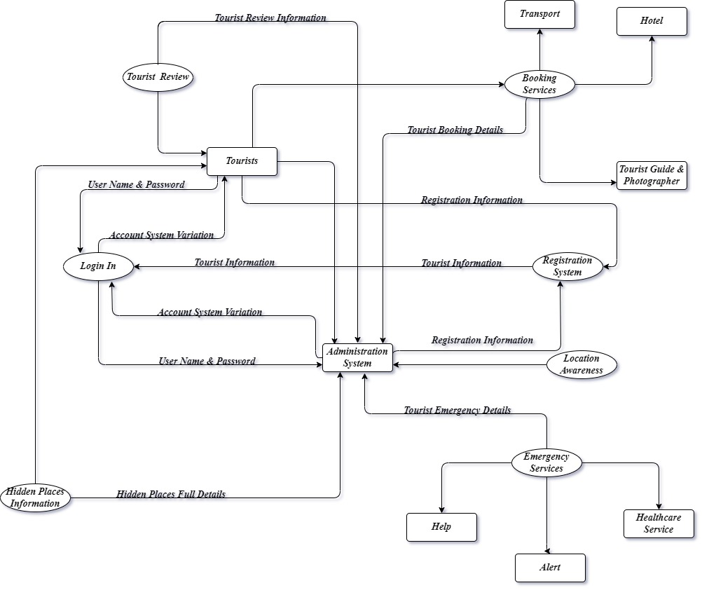

Figure 1 DFD

## **3.1 Competitor analysis - write at least 5 features and do the comparison with 3 similar systems available in the market or that you know**

|  |  |  |  |  |
| --- | --- | --- | --- | --- |
| **Features** | **Diva-Portal.Org** | **Koreascience.Kr/Article** | **Researchgate** | **Freeprojectz** |
| Transports | No | No | No | Yes |
| Tourist Reviews | No | No | No | No |
| Location Awareness | No | Yes | No | Yes |
| Analysis | Yes | Yes | Yes | Yes |
| Easy Booking System | No | No | No | Yes |
| Photographer’s Details | No | No | No | No |
| Hidden Popular Places | No | No | No | No |
| Google Map | Yes | Yes | Yes | Yes |
| Emergency Services | No | No | No | No |

Table 1 Features and similar system

# **4. You should write the work distribution among yourselves and the operational plan based on our deadlines**

* All team members are involved in all activities

|  |  |
| --- | --- |
| **Activity** | **Time period** |
| Group member selecting and fill the form | 26.09.2022 |
| Project proposal discussion with our team | 02.10.2022 |
| Submission of project proposal | 03.10.2022 |
| Group meeting for “How to create SRS document” | 04.10.2022 |
| Documentation work will be started | 06.10.2022 |
| First step of SRS documentation (Introduction, Over all description) | 07.10.2022 - 10.10.2022 |
| Second step of SRS documentation (We are planning to visit the tourism department office in our area) | 12.10.2022 |
| Third step of SRS documentation (Systems features, data requirements, External interface requirements, quality attributes, Other requirements) | 13.10.2022 29.10.2022 |
| Send the SRS document to mentor and get the feedback and approval | 01.11.2022 |
| Submission of SRS | 03.11.2022 |
| Group meeting for how to create progress review presentation | 04.11.2022 |
| Requirement gathering | 05.11.2022 - 08.11.2022 |
| Get project idea | 08.11.2022 - 15.11.2022 |
| Preparing SRS | 16.11.2022 - 18.11.2022 |
| Start design web | 19.11.2022 |
| Complete design web | 25.11.2022 |
| Test plan | 26.11.2022 |
| Complete the test plan | 29.11.2022 |
| Upload our progress review presentation | 02.12.2022 |
| Group meeting for report discussion | 04.12.2022 |
| Create revise architectural diagram | 05.12.2022 - 10.12.2022 |
| Create for UML diagram | 11.12.2022 - 15.12.2022 |
| Progress of the implementation | 16.12.2022 - 22.12.2022 |
| Create test case document | 23.12.2022 - 28.12.2022 |
| Create reflective journal | 29.12.2022 |
| Report submission | 31.12.2022 |
| Group meeting for final report submission | 01.01.2023 |
| Discussion about background of the project | 02.01.2023 - 05.01.2023 |
| Literature Survive and competitor analysis | 06.01.2023 –  08.01.2023 |
| Design our project | 09.01.2023 - 10.01.2023 |
| Development | 11.01.2023 - 12.01.2023 |
| Test results | 13.01.2023 |
| Conclusion | 14.01.2023 |
| Final Report submission | 15.01.2023 |
| Ready for our final presentation | 16.01.2023 - 04.02.2023 |
| Day of final presentation | 04.02.2023 – 07.02.2023 |

Table 2 plan based on our deadlines

**5. Milestones and Reporting**

|  |  |  |  |
| --- | --- | --- | --- |
| **Milestone** | **Responsibility** | **Milestone Deliverables** | **Deliverable Date** |
| Milestone 1 : Form Group |  |  | 27th September, 2022 |
| Milestone 2 : Assignment of Mentors |  |  | 27th September, 2022 |
| Milestone 3 : Project Proposal Submission | Presentation Submission as a Softcopy | Presentation  Literature Review  Existing Problem  Propose Solution  Technology planning to use | 3rd October, 2022 |
| Milestone 4 : Submission of SRS | SRS Submission as a Softcopy |  | 3rd November, 2022 |
| Milestone 5 : Progress Review Presentation | Presentation Slide Submission as a Softcopy | Report Submission  Project idea  SRS  Design  Test Plan | **2nd, 3rd, 4th, 5th December 2022** |
| Milestone 6 : Report Submission | Report Submission as a Softcopy | Revised Architectural Diagram  Revised UML Diagrams  Progress of the implementation  Test Case Document  Appendix (Reflective journal, Meeting minutes) | 31st December, 2022 |
| Milestone 7: **Final Report Submission** | Report Submission as a Softcopy | Background of the Project  Literature Survey & Competitor Analysis  Design  Development  Test Results  Conclusion  Appendix (SRS, Design Document, Reflective journal, Meeting minutes) | 15th January, 2023 |
| Milestone 8: **Final Presentation** |  |  | 4th,5th,6th,7th February 2023 |

Table 3 Milestones and Reporting